## **Issues List**

**1. Issues Title:** The system can not handles invalid (date ranges/ input) for the project titles.

**Reproducing Steps:**

1. Login into the system with valid credentials.
2. Click on the "Project" menu button.
3. Click on the "Add Project" button.
4. Enter a project title in English for both input fields Bangla and English.
5. Click on the "Submit" button.

**Priority: High.**

**Issue Image:**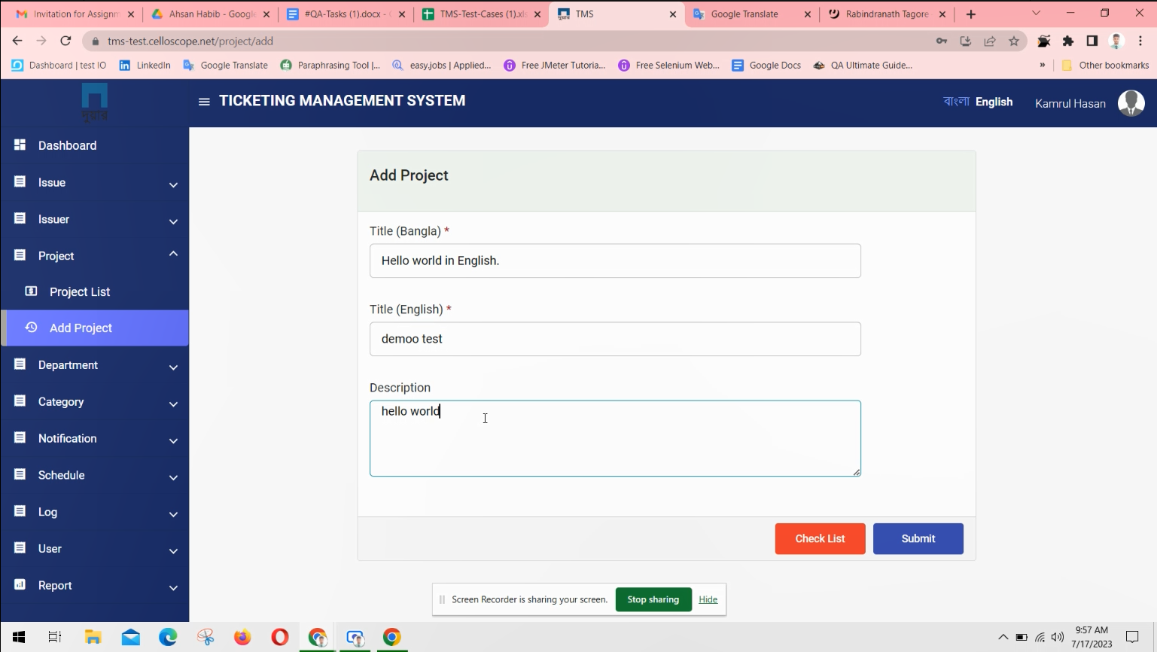

**Video link[** <https://drive.google.com/file/d/1nGOof7qxqA7rPgDwN-tK9_YTOD8PaS-l/view?usp=sharing> **]**

**2.Issues Title:** The system cannot handle special characters in project details/titles.

**Reproducing Steps:**

1. Click on the "Project" menu.
2. Click on the "Add Project" button.
3. Enter project details with special characters (e.g., !@#$%^&*()).
4. Click on the "Submit" button."

**Priority: High.**

**Issue Image:**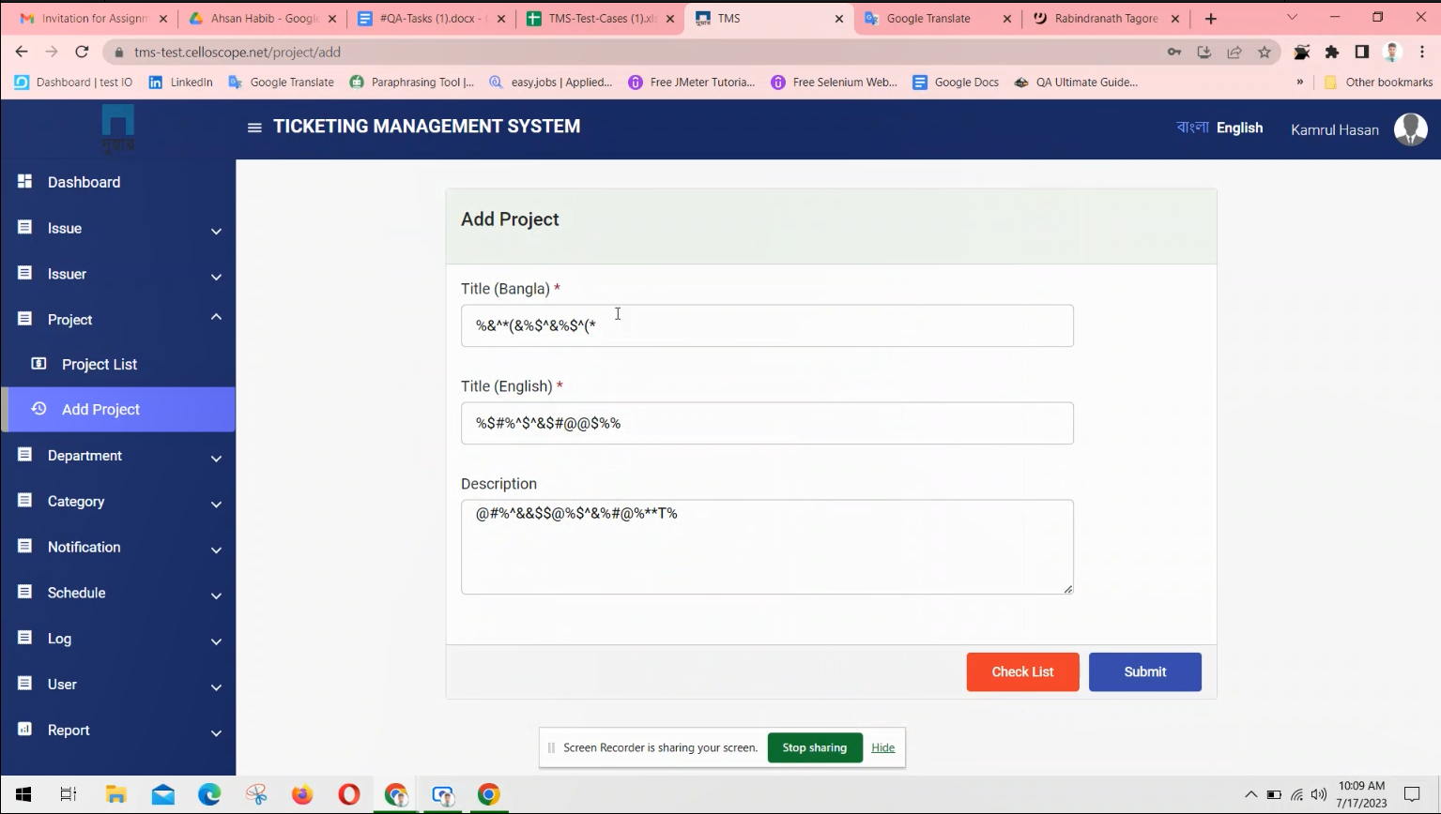

**Video link[** <https://drive.google.com/file/d/1waG2LVEhN9ORRM1HpxpGEwmSQJ6WpZbt/view?usp=sharing> **]**

**3.Issues Title:** Adding projects with Empty / White space input fields.

**Reproducing Steps:**

1. Click on the "Project" menu.
2. Select "Project List"from the submenu.
3. Click on the "Add Project" button.
4. Enter white spaces in the project title field and description field
5. Click on the "Submit"button.

**Priority:** low**.**

**Issue Image:** 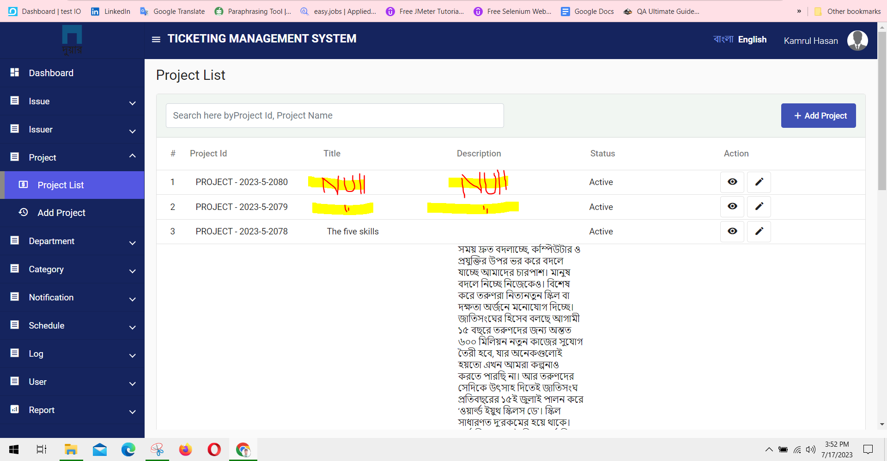

**4. Issues Title:** The system cannot allows undoing the changes made during the edit

**Reproducing Steps:**

1. Click on the "Project" menu.

2. Select "Project List" from the submenu.

3. Locate the project you want to edit from the list.

4. Click on the "Edit" button/icon for the respective project.

5. Modify the project details.

**Priority: Low.**

**Issue Image:** 